EXPERIMENT – 20
Future Sales Prediction using a Suitable Machine Learning Algorithm
AIM
To implement a Future Sales Prediction model using a suitable machine learning algorithm in Python.
APPARATUS REQUIRED
- Google Colab
- Python 3.x
ALGORITHM
- Start the program.
- Import the required Python libraries.
- Create or load the historical sales dataset.
- Preprocess the dataset.
- Separate the input features and sales values.
- Split the dataset into training and testing data.
- Create a suitable regression model.
- Train the model using the historical sales data.
- Predict the future sales values.
- Evaluate the performance of the model using suitable metrics.
- Display the predicted future sales.
- Stop the program.
PROGRAM
# Experiment 20: Future Sales Prediction
# Import required libraries
import numpy as np
import pandas as pd
import matplotlib.pyplot as plt

from sklearn.model_selection import train_test_split
from sklearn.linear_model import LinearRegression
from sklearn.metrics import mean_squared_error, r2_score

# Create sample historical sales dataset
data = {
"Month": [1, 2, 3, 4, 5, 6, 7, 8, 9, 10, 11, 12],
"Sales": [120, 135, 150, 160, 175, 190,
210, 225, 240, 260, 275, 290]
}
df = pd.DataFrame(data)
# Define input and target variables
X = df[["Month"]]
y = df["Sales"]
# Split dataset into training and testing data
X_train, X_test, y_train, y_test = train_test_split(
X, y, test_size=0.2, random_state=42
)
# Create Linear Regression model
model = LinearRegression()

# Train the model
model.fit(X_train, y_train)

# Predict test data
y_pred = model.predict(X_test)

# Calculate performance
mse = mean_squared_error(y_test, y_pred)
r2 = r2_score(y_test, y_pred)

print("Mean Squared Error:", mse)
print("R2 Score:", r2)

# Predict future sales
future_months = np.array([13, 14, 15, 16, 17, 18]).reshape(-1, 1)
future_sales = model.predict(future_months)
print("\nFuture Sales Prediction:")
for month, sales in zip(future_months.flatten(), future_sales):
print("Month", month, ":", round(sales, 2))
# Plot historical and predicted sales
plt.scatter(X, y, label="Historical Sales")
plt.plot(future_months, future_sales,
label="Future Prediction")

plt.xlabel("Month")
plt.ylabel("Sales")
plt.title("Future Sales Prediction")
plt.legend()
plt.show()
OUTPUT
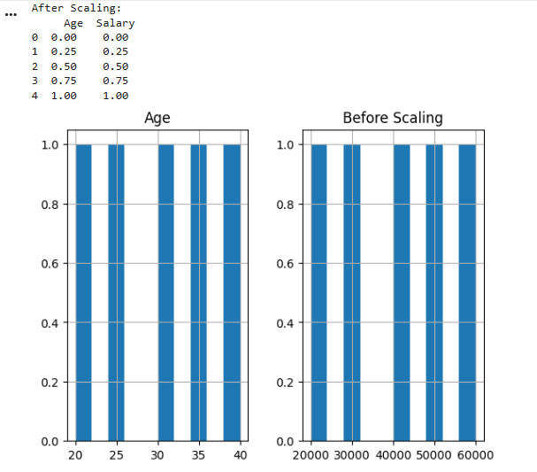
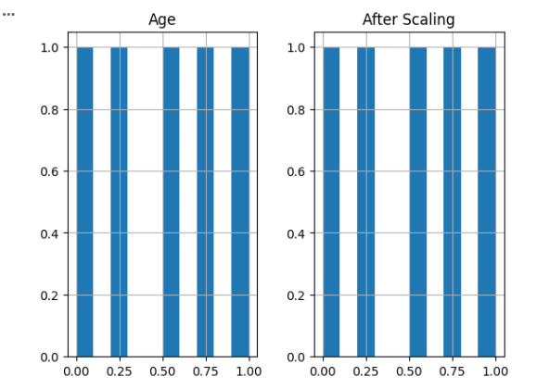
RESULT
Thus, the Future Sales Prediction model was successfully implemented using Python in Google Colab, and future sales values were predicted using the machine learning algorithm.

